Design, Modeling, and Experimental Validation of a Reflux Batch Distillation System for Ethanol-Water Separation
Saroj Basnet¹, Sachin Saud¹, Bikki Chhantyal²*
¹Department of Mechanical and Aerospace Engineering, Pulchowk Campus, Institute of Engineering, Tribhuvan University, Nepal
²Department of Automobile and Mechanical Engineering, Thapathali Campus, Institute of Engineering, Tribhuvan University, Nepal
Email: chhantyalbikki@tcioe.edu.np

ABSTRACT
This study presents the design and experimental validation of a reflux batch distillation system for an ethanol-water mixture under high-altitude conditions. Using barometric relation, local pressure was calculated, and the resulting shifts in the boiling points of ethanol and water were calculated using the Clausius-Clapeyron equation. The Antoine equation with Margules activity coefficient model was used for vapor-liquid equilibrium (VLE). A four-stage distillation column was analyzed using the McCabe-Thiele method, and the relationship between compositions of distillate and bottoms was generated numerically and represented by a cubic spline for efficient numerical simulation. Cumulative distillate concentration, collection rate, and total volume as functions of energy input, stages and reflux ratio are calculated using a time-dependent model implemented in Python. The latent heat requirements, reflux effects, changes in reboiler composition, and volumetric contraction during ethanol-water mixing is incorporated in the model. An experimental prototype consisting of an LPG-fired reboiler, a water-cooled condenser, and a four-stage copper bubble-cap tray column was fabricated and tested with varying feed volumes and concentrations. The model aligned well with experimental results, with relative errors in distillate ethanol concentration below 3.1% (V/V), while collected distillate volume errors ranged from 3.72% to 9.33%. The results show that pressure-corrected thermodynamic modeling can reliably describe batch ethanol distillation at high altitudes, which provides a practical basis for process optimization in small-scale distillation systems.
Keywords: Reflux batch distillation, Ethanol - water mixture, High - altitude operation, Vapor - liquid equilibrium modeling, McCabe - Thiele analysis, Time - dependent distillation, Cumulative distillate concentration
1. INTRODUCTION
Distillation is a fundamental separation process widely adopted in bioethanol production and pharmaceutical applications, aiming at obtaining high - purity solvents and intermediates required for fuel blending and production of drugs and medications [1]. A key challenge in ethanol - water separation by conventional distillation is the presence of a minimum boiling azeotrope at ~95.6 wt% ethanol at 1 atm, making it impossible to produce absolute ethanol. Even with this limitation, conventional distillation is typically the favored technology in most process industries due to its reliable and well - understood nature [1].
Continuous distillation units are typically employed in large - scale bioethanol production facilities as they offer high throughput, consistent output and stable performance. Conversely, batch distillation units, with higher upfront costs, are better suited for pilot plants, research and development labs, pharmaceutical laboratories and for small - scale bioethanol and solvent recovery plants where flexibility in feed compositions is a critical consideration [2].
Even though it's a widely used technology in small - scale facilities, many existing batch distillation units in laboratories are still built based on engineering intuition or experience. In most cases, such systems lack detailed thermodynamic considerations or a robust experimental verification. As a result, these systems suffer from suboptimal energy utilization, inconsistent product quality and insufficient predictive capacity for process improvement.
Several modeling studies have highlighted the need to combine rigorous modeling with experimental verification in batch distillation systems. For example, Bonsfills and Puigjaner [3] formulated a dynamic model of a batch distillation column which was rigorously validated through experiments, whereas Alhaboubi [5] found that employing variable reflux operation allows maintaining near - constant distillate composition with higher energy efficiency than fixed reflux operation. Nonetheless, most published works assume operation at sea - level pressure and at an industrial or pilot - scale scenario. Operating at high altitudes (above 1000 m above sea level) lowers atmospheric pressure. Reduced pressure causes significant alteration in the boiling points of ethanol and water and it drastically changes their phase equilibrium behavior. Guevara - Luna et al. [4] showed that values of parameters obtained for VLE for the binary systemethanol - water under standard pressure aren't directly valid under low - pressure conditions. In spite of its impact, the influence of operating pressure is rarely addressed in laboratory - scale batch distillation models.

1.1 Modeling and Optimization of Batch Distillation

Classical design of distillation columns relies on equilibrium - stage methods like the Rayleigh equation and the McCabe - Thiele diagram, which serve as basic tools for evaluating the separation needed and the number of stages required [8]. These methods are still commonly used in small - scale design and preliminary analysis. However, such approaches are limited in capturing the dynamic nature of batch distillation processes. More rigorous stage - wise dynamic models offer improved prediction accuracy, but their computational complexity makes them less practical for laboratory and decentralized systems. As a result, reduced - order and equilibrium - based dynamic models have been widely adopted. Mujtaba and Macchietto [9] showed that equilibrium - stage formulations can be transformed into time - discretized models that track composition evolution while maintaining mass balance consistency, while Luyben [16] demonstrated the effectiveness of simplified dynamic models.
Accurate thermodynamic data for VLE is crucial to accurately describe batch distillation performance. In particular, for ethanol - water systems, the NRTL (Non - Random Two - Liquid) and UNIQUAC (Universal Quasi - Chemical) models are widely employed due to their ability to account for non - ideal liquid behavior through models for liquid activity coefficients based on local composition and excess Gibbs energy concepts [10,11,12]. For binary systems at moderate pressures, a simpler model such as the Margules equation can provide adequate precision with low computation overhead, thus making it appropriate for use in reduced - order dynamic models [13,14].
Few studies have examined the influence of operating pressure within modeling frameworks. Do et al. [15] highlighted the importance of accounting for pressure variations in distillation performance and energy requirements, while Schwarz et al. [10] emphasized that inconsistent VLE datasets can lead to inaccurate predictions. The mode of operation also significantly influences batch distillation performance. In fixed reflux operation, the distillate composition varies continuously over time, whereas variable reflux strategies improve product consistency and energy efficiency. Alhaboubi [5] demonstrated that variable reflux operation enables near - constant distillate composition with improved energy utilization.
The use of surrogate and machine learning based models for distillation columns has gained attention recently. Bubel et al. [17] developed a set of reusable surrogate models for distillation columns in Aspen HYSYS. Chen et al. [18] developed physics - informed neural networks that learn to model the complex thermodynamics of multicomponent chemical systems from real process data for batch distillation. However, these techniques demand vast amounts of data for training and model tuning, which is typically not available in small laboratory units.
For custom - built, laboratory - scale columns, the performance is further affected by heat losses and instrumentation deficiencies. Ränger et al. [19] examined experimental investigation of thermal losses for pilot scale batch distillation units and Duan et al. [20] quantified the effect of operating pressure on the required heating and cooling duties of an industrial - scale system. These factors show the importance of addressing both energy balance and operating pressure in models of small - scale distillation columns.
Despite considerable advances, most published studies assume standard atmospheric pressure and use commercial simulators. This approach offers limited insight for optimizing small - scale distillation units in locations outside of typical standard pressure and temperature conditions.

1.2 Pressure Sensitivity and High - Altitude Effects
Standard procedures for distillation design, regardless of the application, have commonly assumed sea level atmospheric pressure (101.325 kPa) [21]. The atmospheric pressure at high altitudes (e.g. Kathmandu, Nepal, ~1400 m above sea level) is lower than that at sea level, which in turn directly impacts the boiling temperature of liquids and affects vapor - liquid equilibrium. Battisti et al. [22] showed that the pressure variation allows enhancing the separation in the case of pressure - swing distillation. Guevara - Luna et al. [4] demonstrated that VLE data obtained under atmospheric conditions aren't applicable under low pressure and would result in significant error. Moreover, Duan et al. [20] reported the effect of operating pressure on the energy duties needed to run the distillation column.
Although these studies underline the importance of pressure effects, they primarily focus on industrial systems, with limited attention given to laboratory - scale batch distillation under naturally reduced pressure conditions.

1.3 Experimental Validation in Small - Scale Units
Though much progress has been made in modeling and simulation, actual experimental studies, those based on low - cost, locally available materials and equipment, remain scant. Rougier et al. [23] investigated thermal losses and their impact on small - scale batch distillation, concluding they play a significant role. Barolo et al. [24] performed a thorough investigation of the sensitivity of a batch distillation system to several design and operational parameters, such as number of stages, feed stage location and reflux ratio.
Recent studies are beginning to integrate the benefits of modeling with experimental studies. Zhang et al. [25] obtained results of a batch heteroazeotropic distillation that showed a strong correlation between experiments and simulations. However, similar studies mostly investigate conventional operating conditions and use commercial simulators like Aspen Plus and Pro/II. These limitations highlight the need for integrated approaches that combine simplified modeling with experimental validation under realistic laboratory conditions.

1.4 Summary of Research Gap
There has been a significant body of research focusing on various aspects of batch distillation modeling, thermodynamics and experimental studies. However, few studies have attempted to combine pressure - adjusted VLE modeling, thermal analysis and experimental verification for laboratory - scale batch distillation systems operating at high altitudes.
In particular, the simultaneous effects of low ambient pressure (high altitude), inevitable heat losses due to less efficient insulation and limited instrumentation at the laboratory scale aren't addressed in current literature. This study addresses this research gap by presenting a comprehensive study that integrates altitude - corrected thermodynamic modeling. A lab - scale batch distillation column has been designed, manufactured and operated under different feeding volumes and ethanol concentrations to gather experimental data, which were then employed to test and validate the accuracy of the developed model. The developed equilibrium - stage, time - discretized model provides an understandable and computationally tractable method for simulating batch distillation performance in small - scale, high - altitude environments. Furthermore, this research aims to provide a useful methodology for improvement of small - scale bioethanol purification and pharmaceutical solvent recovery at high altitudes.
2. MATHEMATICAL MODELLING
The performance of the batch distillation unit was evaluated using a framework based on pressure and boiling point adjustment, vapor - liquid equilibrium modeling, energy balance to estimate the power supply and reflux ratio determination. Derivations of all relevant equations are provided in Appendix A.
2.1 Atmospheric Pressure and Boiling Point Adjustment
As experiments were performed in Kathmandu, Nepal (altitude approximately 1300 m), the local atmospheric pressure (652.42 mmHg (86.982.35 Pa)) is different from standard sea level conditions. The pressure at the testing site was derived from the barometric relation. The vapor - liquid equilibrium of the ethanol - water system was estimated by using the calculated atmospheric pressure in the Clausius - Clapeyron relation to get approximate boiling temperatures of 74.28◦C for ethanol and 95.71◦C for water.
2.2 Vapor-Liquid Equilibrium
Vapor - liquid equilibrium of the ethanol - water system was described using Raoult's Law, combined with non - ideal activity coefficients [1].
$$\begin{aligned}y_{i}P = x_{i}γ_{i}P_{sat}\left(T\right)\#\left(1\right)\end{aligned}$$
Here, x_{i} and y_{i} are the mole fractions in the liquid and vapor phases, respectively, activity coefficient is denoted by γ_{i} and P_{sat}(T) is the saturation pressure of component i. The saturation pressure values were found using the Antoine equation and the nonidealities of the liquid phase were estimated by using the two - parameter Margules model.
2.3 Energy Balance and Power Input
Measuring the actual heating supplied by the LPG stove is difficult because of the unavoidable heat loss into the surroundings. To overcome this, the effective power supplied by the LPG burner was calculated by determining the time required for the entire feed volume to reach the boiling point (i. e. , the boiling point of water). The effective heating power was found from experimental heating data using equation (2):
$$\begin{aligned}P_{supplied}=\frac{\left(T_{bpt}-T_{0}\right)\left[ρ_{e}C_{e,0}c_{p,e}+ρ_{w}\left(1-C_{e,0}\right)c_{p,w}\right]V_{0}}{Δt_{d}}\#\left(2\right)\end{aligned}$$
Where T_{bpt} = boiling point of water, T₀ = initial temperature of the feed, C_{e,0} = initial ethanol concentration, V₀ = volume of the feed, ρ denotes the density of the mixture, c_{p} refers to the specific heat and ∆t_{d} = time taken to reach boiling temperature. The heat rejected from the condenser into the surroundings is:
$$\begin{aligned}Q_{cond} =m_{cw}c_{p}\left(T_{out}- T_{in}\right)\#\left(3\right)\end{aligned}$$
Where m_{cw} = mass flow rate of cooling water (kg/s), c_{p} = specific heat of water (J/kg·K), T_{in} = inlet temperature of cooling water, T_{out} = outlet temperature of cooling water and unit of temperature = °C.

2.4 Reflux Ratio
By equating the reflux condenser duty to the difference between the supplied heat and the heat removed by the condenser, we got reflux ratio R from the condenser and reboiler energy balances.
$$\begin{aligned}R =\frac{\dot{n_{R}}}{\dot{n_{D}}}=\frac{Q_{cond}}{P_{supplied}- Q_{cond}}\#\left(4\right)\end{aligned}$$
Where R = reflux ratio, n_{R} = number of moles of reflux, n_{D} = number of moles of distillate, Q_{cond} = reflux condenser heat duty and P_{supplied} = supplied heat power. ,
2.5 McCabe - Thiele Column Analysis
The performance of the column was determined by using the McCabe - Thiele graphical method. The equation for the rectifying operating line is
$$\begin{aligned}y=\frac{R}{R+1}x+\frac{x_{D}}{R+1} \#\left(5\right)\end{aligned}$$
Where x_{D} is the distillate composition.
By construction of the stage - wise calculations, we obtained a direct relationship for bottoms composition (x_{W}) against distillate composition (x_{D}) for the reflux ratio (R), that's, x_{W}(x_{D}), which we converted to x_{D}(x_{W}). We then used cubic spline interpolation (Fig. 11) to find the relationship needed for quick simulations.
The instantaneous distillate composition was then derived from the instantaneous bottoms composition over time. The instantaneous change of bottom composition and quantity depends on the rate of heat applied and reflux ratio and thus the entire process is tracked in steps over the duration of the time period selected.
2.6 McCabe - Thiele Column Analysis
Before performing mass and composition calculations in steps, the total simulation time was approximated from the heating time used experimentally. The simulation process tracks behavior only after the feed reached its boiling temperature (t_{bpt}). The effective simulation time and time - stepping were computed as follows:
Simulation time = t_{total} - t_{bpt},
∆t_{step} = 1 second
$$\begin{aligned}N_{steps} = \frac{60 ×Simulation time}{Δt_{step}}\#\left(6\right)\end{aligned}$$
Where t_{total} = total experimental duration in minutes, Simulation time = time from reaching boiling point to shutoff (minutes), ∆t_{step} = time step size, N_{steps} = number of steps of simulation.
At each time step, the liquid mole fraction in the bottom, distillate volume withdrawn, composition and cumulative masses were updated. The mole fraction in the liquid in the boiler at any given time step (k) is computed from the remaining moles of both ethanol and water as given below:
$$\begin{aligned}x_{W}^{\left(k\right)}=\frac{n_{e,remain}^{k-1}}{n_{e,remain}^{k-1}+ n_{W,remain}^{k-1}} \#\left(7\right)\end{aligned}$$
The corresponding mole fraction in the distillate, x_{D}(k), is obtained from the cubic - spline map generated from the McCabe - Thiele analysis,
$$\begin{aligned}x_{D}^{\left(k\right)}=f\left(x_{W}^{\left(k\right)}\right)\#\left(8\right)\end{aligned}$$
From the heat supplied over the interval ∆t, the moles of distillate withdrawn at each step is determined by (9):
$$\begin{aligned}N_{dist}=\frac{PΔT}{\left(1+R\right)\left(x_{D}M_{w,e} L_{v,e} +\left(1-x_{D}\right)M_{w,w}.L_{v,w}\right)} \#(9)\end{aligned}$$
Where P = heating power supplied, ∆T = time step duration, R = reflux ratio.
The amount of ethanol and water collected at this step is (9):
$$\begin{aligned}∆n_{e} = x_{D}n_{dist}, ∆n_{w} = \left(1-x_{D}\right)n_{dist}\#\left(10\right)\end{aligned}$$
The cumulative mass collected at step k can be determined from cumulative moles collected from step 1 to k as follows:
$$n_{e}^{(k)}=\sum_{i=1}^{i=k}{Δn_{e}^{i}}; n_{w}^{(k)}=\sum_{i=1}^{i=k}{Δn_{w}^{i}}$$
$$M_{e}^{(k)}=n_{e}^{(k)} M_{w,e}$$
$$M_{w}^{(k)}=n_{w}^{(k)} M_{w,w}$$
$$M_{t}^{(k)}=M_{e}^{(k)}+M_{w}^{(k)}$$
The percentage of ethanol (weight-%) in the distillate collected at step k can be derived from (11):
$$\begin{aligned}w_{e}^{\left(k\right)}=\frac{M_{e}^{\left(k\right)}}{M_{t}^{\left(k\right)}} ×100\#\left(11\right)\end{aligned}$$
The density of the ethanol - water mixture, ρ_{mix}(k), at step k can be determined using a cubic - spline interpolation, S(w_{e}), which is constructed from density data available at 20◦C [26] (12).
$$\begin{aligned}ρ_{mix}^{\left(k\right)}=S\left(w_{e}^{\left(k\right)}\right)\#\left(12\right)\end{aligned}$$
The mixed liquid volume collected up to step k is given by (13) while accounting for volume contraction when mixing components:
$$\begin{aligned}V_{mix}^{\left(k\right)}=\frac{M_{t}^{\left(k\right)}}{ρ_{mix}^{\left(k\right)}}\#\left(13\right)\end{aligned}$$
Instantaneous and Cumulative Volume: At each step k, the instantaneous volume of pure ethanol and water collected are derived from the difference in their masses from step k-1 and k (14):
$$ΔV_{e}^{(k)}=\frac{M_{e}^{(k)}-M_{e}^{\left(k-1\right)}}{ρ_{e}}$$
$$\begin{aligned}ΔV_{w}^{\left(k\right)}=\frac{M_{w}^{\left(k\right)}-M_{w}^{\left(k-1\right)}}{ρ_{w}}\#\left(14\right)\end{aligned}$$
Where ρ_{e} and ρ_{w} represent the densities of pure ethanol and water, respectively.
The cumulative volume of pure ethanol and water collected at each step are derived by summing the volumes over all steps up to step k:
$$V_{e}^{(k)}= \sum_{i=1}^{i=k}{ΔV_{e}^{i}}; V_{w}^{(k)}= \sum_{i=1}^{i=k}{ΔV_{w}^{i}}$$
Instantaneous and Cumulative Concentration: The cumulative ethanol concentration (in v/v%) at step k can be derived from the total accumulated volumes as follows:
$$C_{cumu}^{(k)}=\frac{V_{e}^{\left(k\right)}}{V_{e}^{\left(k\right)}+V_{w}^{(k)}} ×100$$
The instantaneous ethanol concentration (in v/v%) for the interval k is derived from the incremental volumes of ethanol and water collected in that time step as:
$$C_{inst}^{(k)}=\frac{ΔV_{e}^{\left(k\right)}}{ΔV_{e}^{\left(k\right)}+{ΔV}_{w}^{(k)}} ×100$$
Both instantaneous and cumulative values were compared with experimentally obtained measurements to validate the model. The inability to accurately control the reflux ratio, heat input and condenser heat duty under its current setup means that experimental data were used as input for the mathematical model.

3. DESIGN AND FABRICATION OF THE APPARATUS
A prototype apparatus was built locally following the guidelines provided by the mathematical modeling. The prototype batch distillation unit was designed in SolidWorks and then fabricated locally.
3.1 Schematic Design
Figure 1 shows a schematic diagram of the batch distillation unit and the process flow. The distillation setup includes five major components: the boiler (or reboiler/feed), the distillation column with bubble cap trays, the reflux condenser, the main product condenser and the distillate collection system. When the batch distillation begins, the feed material is put into the boiler where it's heated, producing a mixture of ethanol and water vapor. The vapor rises through the column and passes through several bubble cap trays that enhance vapor - liquid contact and perform separation. Part of the vapor is then taken to the reflux condenser where a portion of the ethanol and water is condensed and recycled back into the column to achieve a higher purity level of ethanol, the remaining portion is sent to the main condenser where the vapor is completely condensed into distillate, which is collected and later measured to determine its volume and concentration.
The diagram effectively conveys the overall heat and mass transfer and the operation interrelationships between the reboiler, separation stages and both condensers to provide an overview before detailed analysis of individual components.
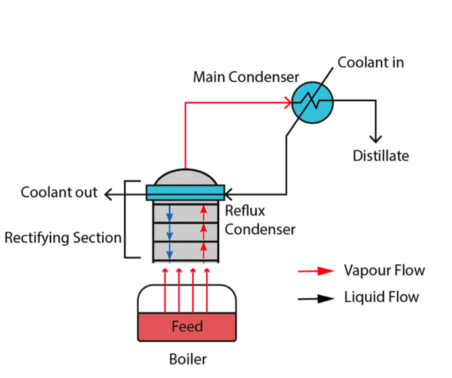
Fig. 1: Schematic diagram of the batch distillation and process flow.
3.2 Overall Design
The apparatus includes the following major components: boiler (or reboiler/feed container), the distillation column, condenser system, three sets of bubble cap trays and the collection system.
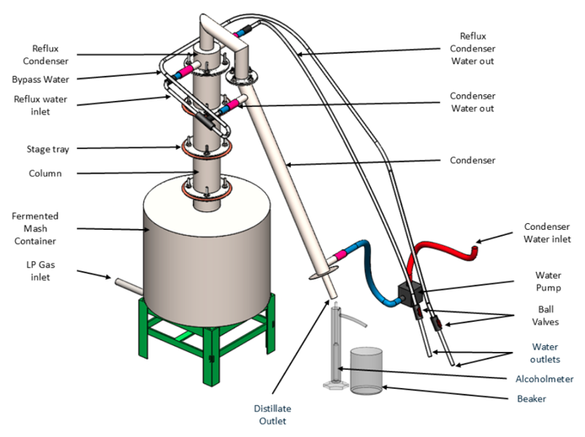
Fig. 2: Overview of the designed batch distillation system.
The boiler is made of stainless steel and is of approximately 29 L capacity. It's heated with a LPG burner, however, induction heating, infrared heating or burning biofuel would also suffice. Based on McCabe - Thiele, the distillation column was sized for four theoretical stages, namely three bubble cap trays in addition to the reboiler stage. A shell - and - tube water - cooled condenser was used. The rate of cooling water into and out of the condenser was controlled. The distillate was collected using a set of graduated glass cylinders to measure its volume and concentration as experiments progressed.
3.3 CAD Model and Fabrication of Major Distillation System Components
Standard machine workshop practices were followed using commonly available materials for approximately two weeks to manufacture the apparatus. Stainless steel was used for the fabrication of the boiler and heating system to prevent oxidation or contamination and improve corrosion resistance. The use of an LPG burner as the heat source was decided due to its local availability and affordability. Figures 3(a) and 3(b) show the CAD models of the boiler and its accompanying components and the distillation column.
A modular design based on stainless steel construction was achieved for the distillation column providing four equilibrium stages. Instead of four bubble cap trays to correspond to four stages, the design includes three bubble cap trays, with vapor - liquid contact occurring also on the boiler stage, thus four stages. The trays were made of copper because it offers high thermal conductivity and it's commonly used in the alcohol distillation process. Each of the trays had a riser and a downcomer to make sure sufficient liquid volume stays in the tray. Bubble cap tray system also used silicone gasket and stainless steel bolts as a sealant for a robust liquid and vapor tight system. The apparatus included both reflux and main product condensers, operating at different conditions and constructed using stainless steel tubing for long life and improved heat transfer. The reflux condenser ran in cross - flow and the main condenser was counter - current in operation.
Cooling water flow rate and rise in temperature across the condensers were used to estimate their duty and the reflux ratio. Adjustable flow control for the cooling water enabled us to conduct experiments at different reflux ratios.
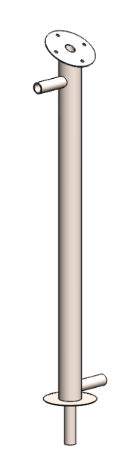
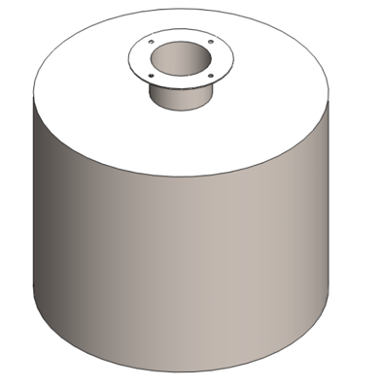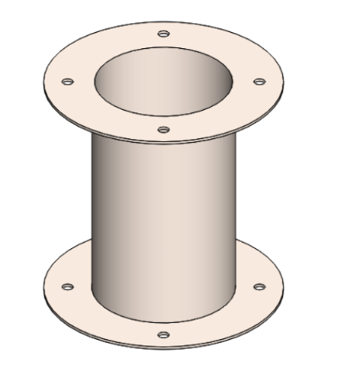
(a) (b)
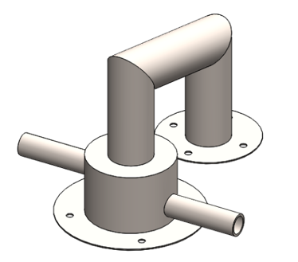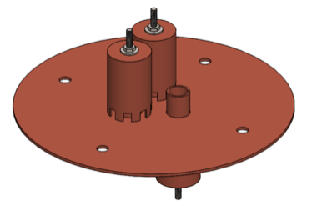
(c) (d) (e)
Fig. 3: CAD model of (a) Boiler, (b) Column unit, (c) Reflux condenser, (d)Bubble cap tray, (e) Main condenser ,
The entire system was assembled using standard bolts and nuts with silicone gaskets for airtight seals and easy disassemblies. The constructed prototype exhibits no noticeable signs of deformation or wear under repeated boiling and condensation cycles, which shows stable, high - quality fabrication for small - scale batch distillation purposes. The photograph of the assembled unit is shown in Figure 4.
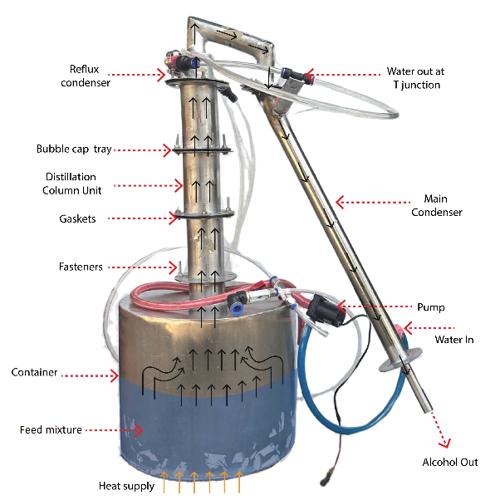
Fig. 4: Fabricated prototype of the batch distillation apparatus, showing the boiler, column, condenser system. ,
3.4 Instrumentation and Measurement
Various measuring devices were incorporated into the apparatus. Thermocouples were placed at locations of the boiler, top of the column, outlet of the reflux condenser and outlet of the main condenser to measure the temperature variation. The volume of distillate collected was recorded using graduated glass cylinders and ethanol content by an alcohol hydrometer (ABV method).
Cooling water flow rates were calculated by using a simple volumetric method where time taken to fill a volume of 1 L was calculated. Each experimental test run included measuring the time to start boiling and duration to stop taking distillate as the bottom mixture volume became low.

3.5 Experimental setup and procedure
Based on the theory, the apparatus was designed to work and test the developed model. Three experiments were run: Run 1 started with distilled fermented mash, the obtained distillate was conditionated and diluted to the initial ethanol (20% by volume) needed, but the final composition was unknown since initial fermented mash may contain 5% ethanol (20/21 = 95.2%), Run 2 fed with distillate recovered from Run 1 and additionally diluted with the distillate obtained in subsequent test runs (27%) and Run 3 was with distillate recovered from Run 2 and with additional ethanol obtained from test runs in the scope of this study diluted to the initial ethanol of 30% (v/v%). Experiments are carried out under Kathmandu's standard operating temperature, hence, the altitude - induced pressure drop was taken into consideration for calculations. Table 1 lists all Operating conditions and environmental initial conditions of the three runs, used as is, with no adaptation to accurately mimic the experiments as stated in the problem's description. For a certain measurement that had been made several times during a specific run, the time average of the obtained measurements are stated. These can serve as valid inputs to calculate parameters and state variables.
TABLE 1: Operating and environmental conditions for experimental runs
Parameters | Run 1 | Run 2 | Run 3
Feed and Initial Conditions
Initial feed volume (L) | 4.0 | 3.0 | 3.5
Initial ethanol concentration (v/v%) | 20 | 27 | 30
Initial feed temperature (◦C) | 18.3 | 15.1 | 17.0
Operating Conditions
Total experimental duration (min) | 40 | 38 | 53
Time to reach boiling point (mins) | 12.00 | 14.08 | 15.67
Ambient temperature (◦C) | 19.1 | 17.0 | 18.0
Condenser and Cooling Water
Cooling-water inlet temperature (◦C) | 25.0 | 20.7 | 25.73
Cooling-water outlet temperature (◦C) | 29.1 | 31.95 | 37.1
Cooling-water flow rate (ml/s) | 36.0 | 11.69 | 9.71

3.6 Instrumentation and Measurements
During each run, the time and its corresponding distillate collected was documented along with various measurements: Heating Time - time to reach boiling point plus several recorded values time, cooling water - inlet and outlet water temperatures and its flow rate and finally, collected distillate amount with its corresponding concentration.

3.7 Experimental Procedure
At the start of each trial, the temperature was recorded and heating was started with LPG. The time required for the mixture to reach the boiling point was registered. As soon as the vapor started to condense, samples were periodically taken out for alcohol analysis. Along with every sample that was taken, temperatures of inlet and outlet cooling - water and cooling water rate were registered. Based on the taken measurements as seen from the listed values for each run in Table 1. The obtained values for each specific run have served as inputs to the model developed as indicated in chapter 4.

4. Results and Discussions
This part covers results from the mathematical model, its Python implementation and tests run. Comparison with theory, operating parameters consistency and lab - scale ethanol - water distillation results, with analysis from theoretical and numerical results to find agreement and discrepancies are performed in this chapter.

4.1 Energy Balance and Reflux Ratio values
In the three experimental runs the heating power supplied can be assessed by using Eq. (2), while condenser duty was evaluated from the experimental cooling rate (Eq. (3)). Reflux Ratio can then be obtained using Eq. (4) given by the refluxing strategy used and can be compared for all test runs in Table 2.
Table 2: Summary of energy balance results for all experimental runs
Parameter | Run 1 | Run 2 | Run 3
Supplied heating power (W) | 1602.49 | 1020.92 | 1025.87
Condenser heat duty (W) | 616.32 | 549.07 | 501.53
Reflux ratio (R) | 0.625 | 1.164 | 0.956

4.2 Vapor - Liquid Equilibrium (VLE) Curve
The Antoine and Margules relations under ambient pressure in Kathmandu, Nepal have been derived using VLE data for binary mixtures. Figure 9 presents the equilibrium curve as calculated by the Antoine - Margules relation model.
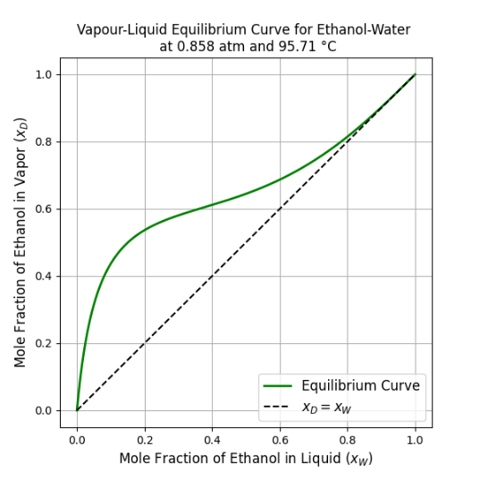
Fig. 5: Vapor - liquid equilibrium (VLE) curve for the ethanol- water system at testing site condition

4.3 Column Performance (McCabe - Thiele Analysis)
In this analysis, 4 theoretical stages are utilized to model the separation behavior along the column. A McCabe - Thiele plot was made and used for demonstration purpose, while we used a cubic spline to interpolate the obtained $x_w$ - $x_D$ data generated by the McCabe - Thiele methodology since finer variations occur in low pure distillate compositions.
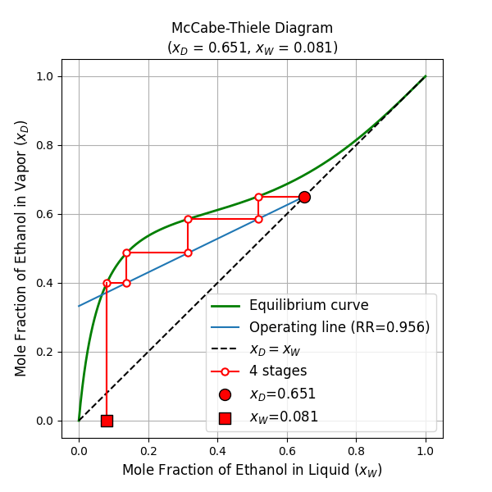
Fig. 6: McCabe - Thiele diagram for the ethanol - water system (4 stages, R = 0.956) for Run 3.
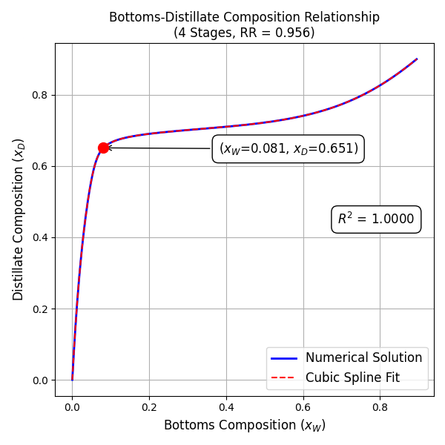

Fig. 7: Bottoms composition vs. Distillate composition for 4 stages at reflux ratio R = 0.956 for Run 3.
In Fig.7, you can observe the effect on the bottom composition as the distillate gets cleaner (higher alcohol). To interpolate the obtained results accurately from the discrete points for computation, we obtained discrete $x_D$ at several $x_w$. For values of low - purity distillate values, which results in steeper McCabe - Thiele curves, a set of closer - to - each - other distillate composition values were generated. With this method, we obtained a curve which we interpolated via a cubic spline.

4.4 Distillate Profiles
The mathematical model developed has predicted the profile of distillation distillate collected as function of time for Run 3 in the form of: cumulative distillate volume versus time, cumulative distillate composition tracking versus time and instantaneously gathered volume per minute versus time. Time 0 is the beginning of heating, whereas Figure 8 starts when the mixture begins boiling point and we collect the first distillate drop.
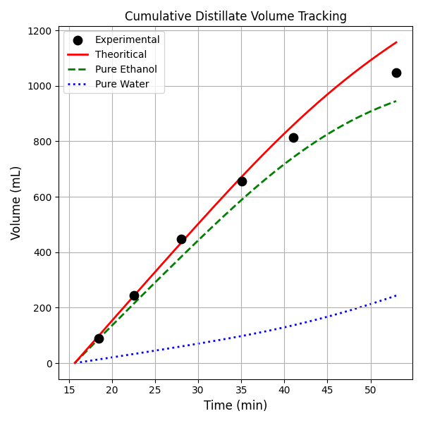
Fig. 8: Cumulative distillate volume collected as a function of time for Run 3.
Theethanol concentration (v/v%) was obtained using pure alcohol volume vs the entire mixture volume as calculated from density for the mixtures which are pure components with densities taken from. As for the cumulative distillate volume, pure alcohol quantity should be calculated and multiplied with density for impure products in a way similar to as what's performed in Eq. 13.
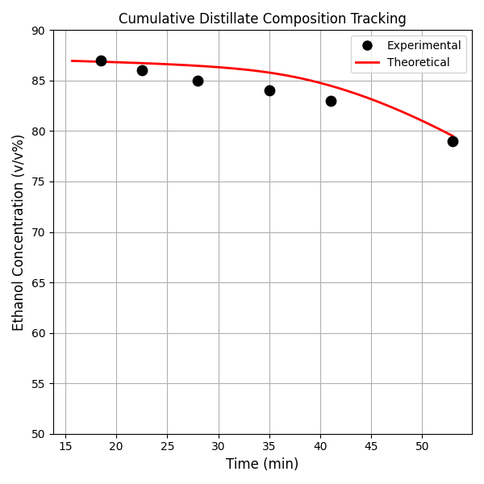
Fig. 9: Cumulative distillate Composition collected as a function of time for Run 3.
A cylindrical graduated vessel of 100 ml was used for the collection of the collected liquid distillate, until a volume close to 90 ml was reached. The elapsed time was registered and divided to calculate the average rate collected per minute. Each collected sample of distillate was tested using an alcoholometer, the measurement point corresponds to the middle of the measured time range for temporal representation.
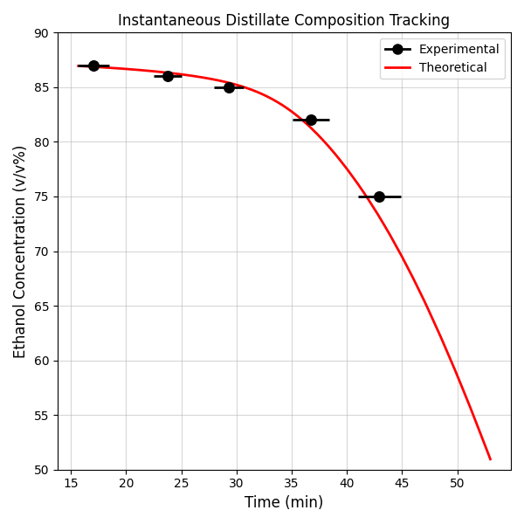
Fig. 10: Instantaneous distillate ethanol concentration as a function of time for Run 3.
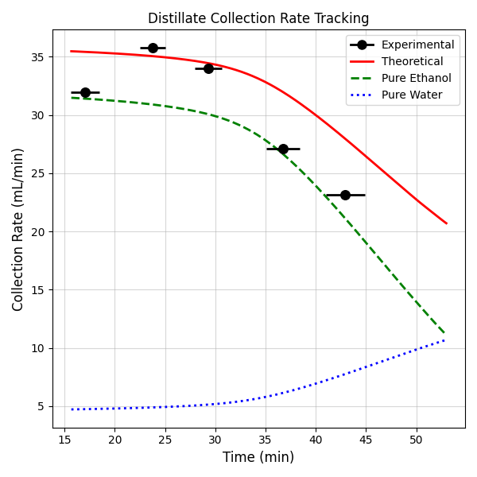
Fig. 11: Instantaneous distillate volume collected per minute for Run 3.
Figure 12 depicts the total quantity collected and increased by volume with time, Figure 13 indicates how the distillate pure alcohol purity evolved through the collection time. Also the instant amount of liquid collected in a minute shown in figure 14 indicates the vapor pressure evolution of ethanol and water vapor pressure over time as ethanol is vaporizing in a slower rate. Both the collected experimental results and the results from the Mathematical Model perfectly match as the graphs lie on top of each other. It demonstrates successful validation that the predicted trend correctly mirrors the real process dynamics: a decrease in collected ethanol pure volume corresponding with gradual depletion of ethanol over the boil up.

4.5 Comparison of Results
Table-3 presents the comparison of measured and the model - predicted outcomes in the terms of the final ethanol volume concentration, total collected distillate, along with deviation between the models with experimental as reference in % error as calculated in section 4.4, for the three runs conducted in Kathmandu, Nepal at specified ambient altitude.
TABLE 3: Comparison of experimental and model-predicted results
Runs | Run 1 | Run 2 | Run 2* | Run 3
Ethanol Concentration (v/v%)
Theoretical | 59.85 | 83.89 | 85.39 | 79.51
Experimental | 58 | 84 |  | 79
Abs. Error | 1.85 | -0.11 | 1.39 | 0.51
% Error | 3.09% | -0.13% | 1.63% | 0.64%
Distillate Volume (mL)
Theoretical | 1227.66 | 719.69 | 609.71 | 1156.94
Experimental | 1182 | 593 |  | 1049
Abs. Error | 45.66 | 126.69 | 16.71 | 107.94
% Error | 3.72% | 17.60% | 2.74% | 9.33%
Run 2* → Diagnostic reconstruction of the simulation for Run 2.
In Table 4, we've the three runs and compared the theoretical outcomes for sea level conditions (atmospheric pressure at 1 atm) and theoretical outcomes corrected to Kathmandu conditions (1 atm - 0.37 bar = 0.63 bar) versus experiment to show pressure drop effect at higher elevation during operation.
TABLE 4: Comparison of Sea-Level and Kathmandu’s model-predicted results
Runs | Run 1 | Run 2 | Run 3
Ethanol Concentration (v/v%)
Sea level | 57.28 | 81.85 | 76.91
Kathmandu | 59.85 | 83.89 | 79.51
% Error | -4.49% | -2.49% | -3.38%
Distillate Volume (mL)
Sea level | 1296.30 | 774.06 | 1226.12
Kathmandu | 1227.66 | 719.69 | 1156.94
% Error | 5.30% | 7.02% | 5.64%

4.6 Discussion of Findings
With this, the model has been tested and has been found to perform sufficiently in simulating the distillation of ethanol water mixture at high altitude regions. It's evident from the experiments that the model manages to capture the temporal change in the collection as well as in ethanol concentration at the end of each runs. For the percentage errors in the total volume collected and pure alcohol collected as percent error, all recorded values are in reasonable amounts, less than 3.1 and 10% for all the experiments. While the accuracy of the model comes out from the energy method that's applied in Eq. 2 and Eq. 3, no particular attention for physical mass flow measurements and rate at which fuel is supplied was observed, nor it needs to. As noticed the difference between experiment versus model for sea level is noticeably higher than for pressure corrected model for the operating environment. From all analyses performed, the correction made to pressure drop at 1 bar in the scope of operation of equipment becomes apparent. Minor discrepancies in results are attributed to the non - ideality of process variables as described below:
Heat and Process Fluctuations: The amount of energy supplied has been calculated to be roughly the energy supplied to the boiler. There's heat loss towards the surrounding through convection and radiation, which in real - life practice reduce the generated vapor quantity, which eventually decreases the vapor production and therefore reduces the collected distillate. On the other hand, fluctuations in cooling water supply led to variation in instantaneous reflux ratio, where average reflux ratios are computed.
Measurement Limitations: The measuring accuracy due to instrumental properties (i. e. , the number of divisions in a graduated cylinder, leastcount of an alcoholometer) as well as human factor (response time for manual measurements) can lead to insignificant errors as these were collected over short duration with manual methods.
Non - ideal Physical effects: Although the mass balance equations formulated in the model describe an ideal scenario, the presence of initial liquid holdup in condenser at start of operation and losses while taking distillate, measuring and transfer. Furthermore, the assumed specific heat capacity which is constant in the temperature range in reality can vary with temperature and also with chemical mixture components, inducing further error as described in the appendix C.
Run Specific Errors:
Run 1: A key impurity added to the fermented mash was the issue of irregular boiling and the resulting, , more irregular and jerky vapor release that has affected the overall heating rate and the rate of distillation.
Run 2: This was the first run when a problem occurred with the mechanical seal on the first bubble cap stage where liquid was observed to drip off the reboiler and down on the outer jacket, creating inventory loss. Thus, a discrepancy between the theoretical and experiment results was found to be 17.6%. As a result, it was decided that to take into consideration inventory loss, leakage coeff $α_{leak}$ be applied to the theoretical molar rate calculated of N_{dist}:
$$N_{dist,corr} =\left(1-α_{leak}\right)N_{dist}$$
Where $α_{leak}=\left(1-\frac{593}{719.69}\right) = 0.176$
Consequently, the predictive volume will rise to 609.71 ml. So this reduces the % error to 2.74%. In terms of pure alcohol collected, the error reduces from 0.13 to 1.63%. All those issues suggest that the volume difference was a matter of pure mass loss and that the vapor - liquid equilibrium (which relates to purity of distillate) worked as expected.
Run 3: Some minor differences at the start of distillation boil - off arise due to liquid remaining on the trays after they arecleaned which gets heated up and eventually becomes the vapour, thus Diluting it in the initial stages.
Even though there have been some issues encountered with running each experimental test run, the overall comparison suggests that the thermodynamic and energy based model has performed successfully as far as theory - based design and investigation at high altitudes for lab scale batch distillation application.
5. Conclusions and Recommendations
In this work, the design, modeling and experimental verification of a small - scale batch distillation system for ethanol - water separation under ambient pressure conditions at Kathmandu have been successfully completed. The developed model incorporated corrections for altitude - dependent boiling temperature, vapor - liquid equilibrium and an energy - based approach for determining the heating power required and the optimal reflux ratio for the distillation process. The McCabe - Thiele method was used to represent the distillation column stages and the model was subsequently developed dynamically to enable the simulation of batch distillation operation.
Three distinct experimental runs were performed using the fabricated distillation apparatus. The heating power delivered to the reboiler and the duty of the reflux condenser were estimated using temperature measurements and relevant cooling water data, which facilitated the indirect determination of the reflux ratio without requiring the use of any flow meters. The same inputs measured during the experiments were then directly inputted into the model without any adjustments to its parameters.
The results obtained from the simulation demonstrated a strong correlation with those obtained from the experiments. In terms of the composition of the distillate, most of the observed deviations were within 3.1%, confirming the accuracy of the model in capturing the dynamic change in ethanol concentration throughout the entire batch distillation process. When comparing the cumulative distillate volume, the maximum errors recorded across all three experimental trials were within 10% following corrections for various mechanical losses encountered in the setup. Furthermore, the model that accounted for altitude corrections provided results that consistently agreed more closely with the experimental data compared to the sea - level model, thereby confirming that an appropriate pressure correction is indeed essential when modeling distillation in the unique atmospheric conditions present in Kathmandu.
Overall, the results indicate that the proposed energy - based approach is adequate and sufficiently robust to effectively describe the principal dynamics of a small - scale batch distillation system without requiring the complexity of directly measuring flow rates. The framework developed in this study presents a practical and physically consistent method that can be readily applied to analyze the behavior of similar systems.
Recommendations for Future Work
For future research efforts, direct measurement of vapor and liquid flow rates would be beneficial to provide additional validation of the estimated reflux ratio determination method. Enhancements in the insulation of the distillation setup and improved methods for estimating heat loss to the surroundings could lead to a reduction in uncertainties related to predicting the total volume of distillate collected. The implementation of an automated reflux control system would also contribute to improving the consistency of the product obtained during the batch distillation process.
Additionally, there's potential to explore the application of machine learning (ML) techniques to further enhance and extend the developed modeling framework. By systematically varying crucial parameters such as the reflux ratio, heating input, the number of theoretical stages within the column and the initial composition of the feed, a much larger dataset can be generated for comparative analysis and model training. Data - driven models could then be developed and trained to accurately predict various output variables, including the distillate composition, the total energy consumption required or the reflux behavior under different operating conditions. This would pave the way for the creation of comparative performance graphs and the development of faster prediction tools, obviating the need to run full simulations every time specific predictions are required. Integrating ML methodologies with the existing physics - based model could synergistically improve predictive capabilities and provide essential support for real - time monitoring and control of small - scale batch distillation systems.
Acknowledgements
We'd like to express our sincerest gratitude to the Mechanical Engineering Department at Pulchowk Campus, IoE, for allowing us access to the necessary laboratory facilities and equipment during the construction and testing phases of our project. We owe special thanks to Vishwo Prasanna Amatya and Laxman Motra and to the dedicated lab staff for providing invaluable guidance and unwavering support throughout all aspects of the fabrication and testing process. We are also deeply thankful for the generous financial support provided by FSU-2079, without which this project wouldn't have been possible. Finally, a huge thank you to my project teammates, Sanjiv Pahari and Madan Ghimire, along with all of our friends and classmates who offered assistance during fabrication and testing and who provided us with consistent encouragement from the initial design conception all the way up to our final experimental run.

REFERENCES
[1] R. H. Perry and D. W. Green, Perry’s Chemical Engineers’ Handbook, 7th ed. New York, NY, USA: McGraw-Hill, 1999.
[2] I. M. Mujtaba, Batch Distillation: Design and Operation. London, UK: Imperial College Press, 2004. doi: 10.1142/5300.
[3] A. Bonsfills and L. Puigjaner, “Dynamic simulation and control of batch distillation processes,” Chemical Engineering and Processing: Process Intensification, vol. 43, no. 12, pp. 1541–1558, 2004. doi: 10.1016/j.cep.2004.08.002.
[4] M. A. Guevara-Luna, F. A. Guevara Luna, and L. C. Belalcázar, “Experimental data and new binary interaction parameters for ethanol–water vapor–liquid equilibrium at low pressures using NRTL and UNIQUAC,” TECCIENCIA, vol. 13, no. 24, pp. 17–26, 2018.
[5] N. A. Alhaboubi, “Constant distillate composition of batch distillation column with variable reflux mode based on still pot concentration,” Science and Technology for Energy Transition, vol. 77, no. 2, 2022. doi: 10.2516/stet/2021002.
[6] Sholl, D. S., & Lively, R. P. (2016). Seven chemical separations to change the world. Nature, 532(7600), 435–437.
[7] Sorensen, E. (2014). Design and Operation of Batch Distillation. In Distillation: Fundamentals and Principles (pp. 187–224). Academic Press.
[8] McCabe, W. L., Smith, J. C., & Harriott, P. (1993). Unit Operations of Chemical Engineering (5th ed.). McGraw-Hill.
[9] Mujtaba, I. M., & Macchietto, S. (1997). Optimal operation of batch distillation. Computers & Chemical Engineering, 21(6), 651–665.
[10] Schwarz, C. E., Müller, J., Hasse, H., & Jirasek, F. (2024). Effect of variation between different experimental vapor–liquid equilibrium data sets on NRTL correlations. Industrial & Engineering Chemistry Research, 63.
[11] Renon, H., & Prausnitz, J. M. (1968). Local compositions in thermodynamic excess functions for liquid mixtures. AIChE Journal, 14(1), 135–144.
[12] Abrams, D. S., & Prausnitz, J. M. (1975). Statistical thermodynamics of liquid mixtures: A new expression for the excess Gibbs energy. AIChE Journal, 21(1), 116–128.
[13] Smith, J. M., Van Ness, H. C., & Abbott, M. M. (2005). Introduction to Chemical Engineering Thermodynamics (7th ed.). McGraw-Hill.
[14] Xiong, Y., Li, J., Zhang, P., & Li, X. (2021). Study on vapor–liquid equilibrium data and correlation for binary systems based on simplified activity coefficient models. Journal of Chemical & Engineering Data, 66(4), 1234–1246.
[15] Do, X.-T., et al. (2024). Experimental study and process modeling of vacuum batch rectification columns. Applied Thermal Engineering.
[16] Luyben, W. L. (2020). Batch distillation simulation using Aspen Plus. Computers & Chemical Engineering, 141, 106993.
[17] Bubel, M., Seidel, T., & Bortz, M. (2025). Reusable surrogate models for distillation columns: A machine learning approach. arXiv preprint arXiv:2509.06638.
[18] Chen, H., et al. (2024). Physics-informed neural networks with hard linear constraints for thermodynamic modeling. arXiv preprint.
[19] Ränger, L. M., et al. (2023). Experimental Investigation of Heat Losses in a Pilot-Scale Multiple Dividing Wall Distillation Column with Three Parallel Sections. Processes, 7(4), 68.
[20] Duan, W., et al. (2022). Comprehensive analysis and targeting of distillation process heat integration with pressure variation. Processes, 10(9), 1861.
[21] Luyben, W. L. (2013). Distillation Design and Control Using Aspen Simulation (2nd ed.). John Wiley & Sons.
[22] Battisti, R., Claumann, C. A., Marangoni, C., & Machado, R. A. F. (2019). Optimization of pressure-swing distillation for anhydrous ethanol purification by the simulated annealing algorithm. Brazilian Journal of Chemical Engineering, 36(1), 453–469.
[23] Rougier, M., Bellettre, J., & Luo, L. (2021). An experimental study of a wine batch distillation in a copper pot still heated by gas. Energies, 14(11), 3352.
[24] M. Barolo, B. Chiavarino, and A. Botteon, “Calculation of parametric sensitivity in binary batch distillation,” *Chemical Engineering Science*, vol. 53, no. 17, pp. 3057–3067, 1998. https://doi.org/10.1016/S0009-2509(98)00017-7
[25] C. Zhang, H. Ke, and B. Zhang, “Process design, simulation and experimental studies of heteroazeotropic batch distillation for dehydration of water-bearing phenols,” Chemical Engineering and Processing: Process Intensification, vol. 180, 2023.
[26] The Engineering ToolBox, “Ethanol water mixtures - densities vs. temperature,” https:// www.engineeringtoolbox.com/ ethanol-water-mixture-density-d_2162.html, 2019, [Accessed: 28-11- 2025].

APPENDIX
APPENDIX A: MATHEMATICAL DERIVATIONS
This appendix presents the detailed derivations of the equations used in the modeling and analysis of the batch distillation apparatus.
Atmospheric Pressure at Altitude
Atmospheric pressure decreases with altitude h according to the barometric relation:
$$\begin{aligned}P\left(h\right)= P_{0}\exp\left(-\frac{gM_{air}h}{R_{g}T}\right)\#\left(A.1\right)\end{aligned}$$

where P₀ is the sea-level pressure, g is gravitational acceleration, M_{air} is the molar mass of air, R_{g} is the universal gas constant, and T is ambient temperature in Kelvin.
Boiling Point Correction (Clausius- Clapeyron)
The shift in boiling point with pressure was obtained using the Clausius-Clapeyron relation:
$$\begin{aligned}\ln\left(\frac{P_{2}}{P_{1}}\right) =-\frac{H_{vap}}{R}\left(\frac{1}{T_{2}}-\frac{1}{T_{1}}\right)\#\left(A.2\right)\end{aligned}$$

where P₁, P₂ are pressures at temperatures T₁, T₂ respectively, and ∆H_{vap} is the enthalpy of vaporization.
Vapor-Liquid Equilibrium (VLE)
For the ethanol-water system, the equilibrium vapor composition was computed using Raoult’s law with activity coefficients:
$$\begin{aligned}y_{i}P = x_{i}γ_{i}P_{i}^{sat}\left(T\right)\#\left(A.3\right)\end{aligned}$$
where x_{i} and y_{i} denote the liquid- and vapor-phase mole fractions, γ_{i} is the activity coefficient, and P_{i}^{sat}(T) is the temperature-dependent saturation pressure of component i.
Antoine Equation:
$$\begin{aligned}\log_{10}[{P_{i}^{sat}\left(T\right)]} = A_{i} -\frac{B_{i}}{T+C_{i}}\#\left(A.4\right)\end{aligned}$$

where T is in °C and P_{i}^{sat}(T) is in mmHg. The Antoine constants for the ethanol-water system are [30]:
Ethanol: A = 7.58670, B = 1281.590, C = 193.768
Water: A = 8.07131, B = 1730.630, C = 233.426
Margules Activity Coefficient Model: Liquid-phase nonideality was represented using the two-parameter Margules equations:
$$\begin{aligned}\ln{γ_{e}}= x_{w}^{2} \left[A_{ew} + 2x_{e}\left(A_{we} - A_{ew}\right)\right] \#\left(A.5\right)\end{aligned} \\ \begin{aligned}\ln{γ_{w}}= x_{e}^{2} \left[A_{we} + 2x_{w}\left(A_{ew} - A_{we}\right)\right]\#\left(A.6\right)\end{aligned}$$
where x_{e} and x_{w} are the liquid mole fractions of ethanol and water, respectively. The parameters A_{ew} and A_{we} are empirical interaction coefficients obtained from ethanol-water VLE measurements. The parameters used in this model are[25]:
A_{ew} = 1.6022, A_{we} = 0.7947.
Vapor Mole Fraction Expression: Combining Raoult’s law, the Antoine equation, and the Margules model yields the vapor-phase mole fraction of ethanol:
$$\begin{aligned}y_{e} = \frac{γ_{e}x_{e}P_{e}^{sat}}{γ_{e}x_{e}P_{e}^{sat}+ γ_{w}x_{w}P_{w}^{sat}} \#\left(A.7\right)\end{aligned}$$
This expression was evaluated pointwise to create a VLE Curve.
Reflux Ratio Derivation
The derivation of the reflux ratio assumes quasi-steady operation, negligible sensible heat contributions, and constant latent heat of the mixture. The reflux condenser is assumed to condense only the reflux vapor stream, while the main condenser handles the distillate. Heat losses to the surroundings are considered negligible, and cooling water temperature and flow are assumed uniform.
The reflux ratio was determined from an energy balance between the reflux condenser and the reboiler. The heat removed by the cooling water in the reflux condenser is:
$$\begin{aligned}Q_{cond} =\dot{m_{cw}} c_{p} \left(T_{out} - T_{in}\right)\#\left(A.8\right)\end{aligned}$$
Where $m_{cw}$ is the mass flow rate of cooling water (kg/s), c_{p} is the specific heat of water (J/kg·K), and T_{in} and T_{out} are the inlet and outlet temperatures of the reflux cooling water (°C). The heat released by the condensed reflux vapor is proportional to the reflux flow rate:
$$\begin{aligned}Q_{ref}=\dot{n_{R}}H = R\dot{n_{D}}H \#\left(A.9\right)\end{aligned}$$
where $\dot{n_{R}}$ is the molar reflux flow rate, $\dot{n_{D}}$ is the molar distillate flow rate, R is the reflux ratio, and H is the average molar latent heat of the mixture:
$$\begin{aligned}H = x_{D}M_{e}L_{e} + \left(1- x_{D}\right)M_{w}L_{w}\#\left(A.10\right)\end{aligned}$$
The total vapor flow generated by the reboiler is related to the supplied power:
$$\begin{aligned}P_{supplied} =\left(\dot{n_{D}}+\dot{n_{R}}\right)H=\dot{n_{D}}\left(1 + R\right)H \#\left(A.11\right)\end{aligned}$$
Combining Eqs. (A.8)-(A.11), the reflux ratio can be expressed directly in terms of the condenser heat removal and the supplied power:
$$\begin{aligned}R = \frac{Q_{cond}}{P_{supplied} - Q_{cond} } \#\left(A.12\right)\end{aligned}$$
APPENDIX B: CODE REPOSITORY
The Python scripts and related materials are available online at: https://github.com/basnetsaroj/Batch_distillation_paper

